***Trajectory and character of oyster growth under altered total alkalinity and salinity***

1,2Saley, Alisha M., 2Kimball, Zoe & 1,2Brian Gaylord

1 Bodega Marine Laboratory, University of California Davis

2 Dept. of Ecology and Evolution, University of California at Davis

***Abstract—*** Sessile organisms in dynamic estuarine environments experience sudden, step-like changes to seawater carbonate conditions and salinity, that may persist for long periods. Specifically for shell-building species that conform to external seawater conditions, the window of exposure along a trajectory could have import for the character of response. Little is known, however, about how organisms respond to altered conditions through the course of an exposure. Here, we compare the effect of TA and salinity on juvenile *Crassostrea virginica* (Eastern oyster) growth in two time windows, one corresponding to immediately after the exposure (0 – 18 days) and another later (19 – 36 days). We measured growth in shell area of oysters across a range of total alkalinities, within 2 salinities (Samb = 34, Slow = 27) that might be expected for coastal estuaries receiving stream inputs. In addition to growth through time we measured to overall growth (0 – 36), and account for potential disruptions to vertical shell growth and tissue mass with measurements of shell thickness (mg2 mm-2), and condition index (mg mg-1), Results demonstrate that oyster growth in shell area responded to altered TA in two distinct patterns, with no effect of TA in the earlier window, even though the lowest TA resulted in corrosive seawater conditions, and a positive effect in the later window. The scale of growth declined in the later window, which may indicate a strong role of biological shell building activity in off-setting shell loss from corrosive seawater. We did not see deleterious consequences to shell thickness or condition index, similar to other well-fed calcifiers that cope with otherwise, stressful conditions. Our work begets the need to consider how growth patterns measured here may intersect with other physiological pathways, and the extent to which other calcifiers respond similarly, in order to better gauge how species may cope with current and futures seawater change.

***Introduction—*** Coastal estuaries exhibit variability in the seawater carbonate system, with implications for calcifying inhabitants. For example, biogeochemical processing and river inflows can create deviations in total alkalinity (TA) from open-ocean values (Hunt et al. 2011, Fassbender et al. 2016, Montagna et al. 2018). Likewise, salinities can be modulated (Hollarsmith et al. 2020). Estuarine conditions are also temporally complex, with TA and salinity changing abruptly, often in conjunction with storms or seasonal shifts, and then persisting for days to months (Najjar et al. 2020, Ricart et al. 2021, Bartoloni et al. 2023). Such dynamics require that sessile calcifiers conform to new conditions and then endure them for sometimes extended durations. Given the multi-faceted extent to which seawater conditions dictate physiological and ecological performance of marine calcifiers (Hofmann and Todgham 2010, Gaylord et al. 2015), investigating responses to variation in TA and salinity deserves detailed attention.

Global perturbations to the carbonate system are likely to intersect with the effects of variation in total alkalinity and salinity . Approximately a third of human-produced carbon dioxide emitted to the atmosphere absorbs into the oceans (Sabine et al. 2004). Changes to multiple components of the carbonate system of seawater ensue (causing ‘ocean acidification;’ Caldeira and Wickett 2003). Meanwhile, global warming is increasing the frequency and magnitude of extreme precipitation events, which can result in stronger reductions to salinity than normal. Thus, both small- and large-scale processes governing variation in TA and S operate within estuaries and can impact the ability of shell-forming taxa to precipitate their calcium carbonate structures.

Substantial effort has documented how calcifier growth can be disrupted by an altered carbonate system, largely focusing on the change in a response between a start and end time point, both within and across life stages (**cite** list). A subset of this work has emphasized effects of temporal characteristics of exposure (e.g., static versus fluctuating conditions, often of pH or CO2) (Mangan et al. 2017). However, gaps remain in our understanding of whether responses to sudden changes in the carbonate system manifest quickly or build up more slowly, and whether responses continue to hold or abate as perturbed conditions persist. Such “step change” exposures are not uncommon in nature, and their durations can differ across systems and localities. Therefore, information regarding the trajectory of calcifier responses across time is valuable. These points become especially relevant to dissecting potential physiological trade-offs in energy allocation – for example among growth (shell or tissue), reproduction, movement, and maintenance – each of which has its own time course and metabolic pathway (for ex. see Kroeker et al. 2014).

Explorations of how growth rate responds to altered TA and S are especially suited to extending prior work. For example, extensive research has documented disrupted growth in bivalves under ocean acidification (for review see Gazeau et al. 2013, Shi and Li 2023), but few if any of these studies have deliberately examined effects of modifying TA. Similar limitations in experimental manipulation of TA apply to crustaceans and echinoderms, that have demonstrated variable and broad tolerance to OA conditions, respectfully (see reviews Dupont et al. 2010, Whiteley 2011). Strong drops in salinity are likewise known to affect growth (Pourmozaffar et al. 2020). However, potential correlations between decreased salinity and TA may have unintentionally blurred the relative importance of these two factors in many such studies. Therefore, explicit tests of effects of TA and salinity on calcification abilities of coastal and estuarine taxa are needed.

Oysters have significant economic and ecological value to coastal populations of humans and wild organisms alike. Because many oyster species create structure-forming reefs, they often provide habitat for other estuarine taxa (Coen et al. 2007). Moreover, they help protect against shoreline erosion from waves (Wiberg et al. 2019). Commercially, when reared and harvested for human consumption, they contribute to a globally-expanding shellfish diet (Santeramo et al. 2017). In the latter context, relative and absolute amounts of shell and tissue mass become relevant.

Here we explore how total alkalinity and salinity affect growth of juvenile Eastern oysters (*Crassostrea virginica*), with special attention to the trajectory of a response across two time windows, relative to overall, to step changes in seawater TA and salinity. In particular, we examine how growth in shell area differs between an earlier time window, starting immediately after altering treatment conditions, and a later time window two weeks later. In these efforts we also account for the size of oysters at the beginning of each time window. At the end of the experiment, we additionally compare a metric of oyster shell thickness (shell mass per area) and condition index (tissue mass per shell mass) across different TA and salinity exposures. Examinations such as these lend insights into ways in which calcifying estuarine species may respond across time to abrupt and persisting changes to seawater carbonate chemistry.

***Methods—***

**Study species—** The Eastern oyster, *Crassostrea virginica*, is native to estuaries of eastern North America, from the Gulf of St. Lawrence to the Gulf of Mexico (**cite**). Due in part to its wide salinity and thermal tolerance, this species is also grown commercially elsewhere, including the west coast of the US and Hawaii. For our experiments, we sourced juvenile oysters from a local aquaculture farm in Tomales Bay, California, USA (Hog Island Oyster Company; **38.162327, -122.893489**). On 22 July 2022, we transported oysters in cool seawater from Tomales Bay to the UC Davis Bodega Marine Laboratory (BML; Bodega Bay, California, 60 min transit time), and placed them immediately into flow-through, continuously bubbled seawater drawn from the adjacent ocean. We fed the oysters with slow-release mixed algal diet (5% of their wet mass with thawed whole-cell concentrate of *Tetraselmis*, *Thalassiosira* *weissflogii*, *T. pseudonana*, and *Schizochytrium*, Reed Mariculture) once every two days, throughout a 30-d lab acclimation period. At the end of the acclimation period, we glued the oysters (left valve) to plastic plates using **X** marine epoxy (n = 49 per plate, n = 12 plates). We then returned the plates with attached oysters to the acclimation tanks, and three days hence began a 36-d growth experiment (Fig. 1).

**Design of experiment—** Our primary aim was to determine effects of total alkalinity on oyster shell growth. We established six treatment levels of TA, spanning conditions characteristic of estuaries with substantial rainwater input (low TA, 800-1500 umol kg -1), through more typical alkalinity conditions (intermediate TA, 2000 – 2200 umol kg -1), to conditions observed in estuaries supplied by watersheds of high-carbonate geology (high TA, > 2200 umol kg-1). Because streams and rivers that deliver low- or high-TA fresh water can simultaneously decrease estuarine salinity, we also established two treatment levels of salinity, an ambient level (S=34) and a reduced salinity level (S=27). The resultant experimental design linked treatments of both lower and higher TA with both low and ambient salinity. Although the treatment conditions were not fully orthogonal (Fig. 1), this design enabled exploration of independent effects of TA and salinity across a spectrum of environmental conditions relevant to *C. virginica*. Each TA and salinity treatment combination (6 total) was replicated across two static culture chambers, each containing one plate with 49 attached oysters. The overall configuration thus summed to 49 oysters x 2 cultures x 6 treatments = 588 oyster individuals across the experiment.

We were additionally interested in whether oysters might respond in a different way immediately following exposure to a novel set of TA and salinity conditions, compared to a response later on after the exposure had continued for multiple days. We therefore sampled growth in shell area at several time points throughout the 36-d experiment, focusing especially on growth across two time windows, one earlier (days 0-18) and one later (days 19-36).

**Oyster growth—**We tracked changes in shell surface area throughout the experiment, taking photos of shell area on day 0, day 18, and day 36. We analyzed the photos using ImageJ software (v.1.53t) to determine projected surface area of each oyster’s top valve, ensuring a scale bar was visible in each image. We quantified the growth in shell area (difference in shell area between start and end dates) within earlier and later windows, and the overall shell growth across the full 36 days of the experiment. We additionally measured condition index at day 36, which we quantified as dry tissue mass per dry shell mass, after separating the tissue from the shells and drying each at 60°C for 48 hr. We then divided shell mass by shell area to develop a rough metric of shell thickness.

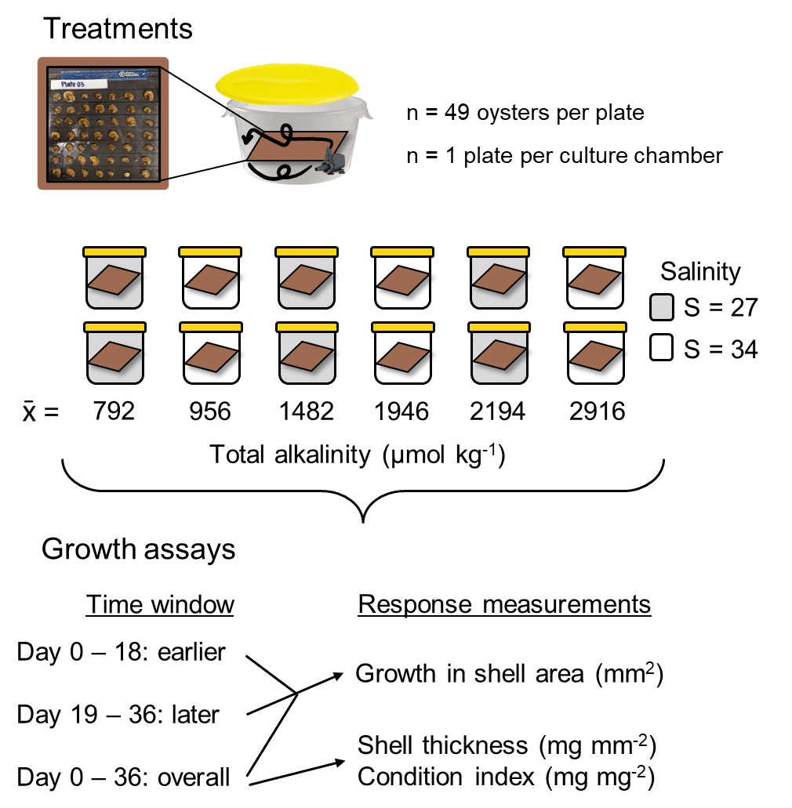

**A**

**B**

Fig. 1. Schematic of A) experimental culture conditions and B) growth responses that were measured through time. Across two salinity levels, we employed 6 TA conditions, duplicating each TA-salinity combination. One oyster plate was assigned to each culture chamber for the 36-day experiment. We measured growth in shell area in an earlier and later window *growth in shell area* in an early (Day 0 - 18) and later (Day 19 - 36) window. We measured *overall* shellgrowth (per 36 days), shell thickness (mg mm-2), and the condition index (mg mg-2) at the end of the experiment.

**Culture conditions—** Each static culture during the experiment included an aquarium pump to ensure adequate water motion. The continuous stirring allowed gas exchange at the water’s surface to keep oxygen levels at >80% saturation . The only exceptions were two cultures that dropped to ~70% on one occasion each, due to pump failure. The resulting episodes of decreased oxygen lasted less than 8 hr. Oysters were fed daily with shell-fish mixed algal diet, and were held in the dark to minimize the influence of shadows on activity (cite). Complete water changes were done every three days, and the sides of the culture chambers, and pumps, cords, and tubing were cleaned of any fouling organisms and debris. The experimental cultures had lids but were not tightly sealed due to a gap created by the pump power cord, which resulted in minor chemical drift between water changes (Fig. 2). Despite this drift, chemical conditions across treatments remained distinct and differed statistically. Any mortality of oysters was recorded at the same time as water changes, and shells of deceased oysters were promptly removed from the cultures and discarded (< 15% overall mortality in all chambers).

Before and after each water change during the experiment, we measured seawater temperature, salinity, pH, and dissolved oxygen concentration with a handheld multi-parameter sensor (YSI X). In 50% percent of pH measurements, we collected and analyzed discrete bottle samples for spectrophotometric determination of pH (calibrated on the same day with m-cresol dye standards, Easley and Byrne 2015), and used the latter data to translate pH data to the total scale. We also collected and immediately froze 250 ml seawater samples before and after each water change for later alkalinity determination. We quantified seawater TA in triplicate using a Metrohm 855 Titrosampler, correcting titration acid concentration daily with certified reference materials from the laboratory of Dr. Andrew Dickson (Scripps Institute of Oceanography). Finally, we used measurements of seawater TA (µmol kg-1) and pH (total scale) at specified salinities and temperatures to estimate the remaining seawater carbonate system parameters with the *seacarb* package in the software R (version 3.3.1). In our *seacarb* estimates, we used equilibrium constants from Lueker et al. 2000 (K1 and K2), Perez and Fraga 1987 (Kf), and Dickson 1990 (Ks). For simplicity, we refer to the seawater carbonate system in terms of TA, though additional carbonate system parameters vary in conjunction with shifts in alkalinity (Table S1), some of which may influence oyster growth separately from salinity and TA.

**Chemical manipulation of seawater—** Seawater chemical conditions at the beginning of the experiment and at each water change were established as follows. We first depleted seawater TA to negligible concentrations in large sumps (n = 4 sumps/water change) by adding hydrochloric acid (HCl) to drive the carbonate system reactions towards CO2, which then off-gassed over two days in conjunction with strong bubbling with air. We then mixed the TA-depleted seawater with distilled fresh water and premade solutions of NaHCO3 (sodium bicarbonate) and Na2CO3 (sodium carbonate) with HCl to adjust the carbonate system back to desired salinity and TA levels (Waldbusser et al. 2015, Ninokawa et al. in review).

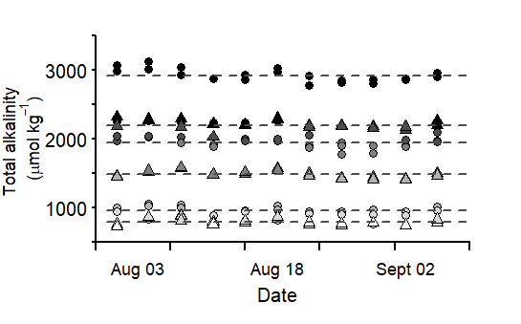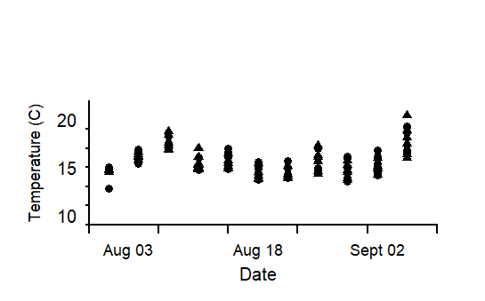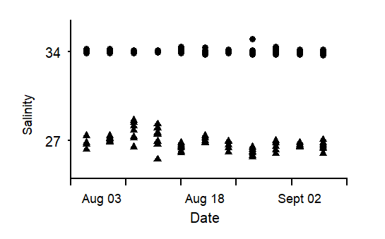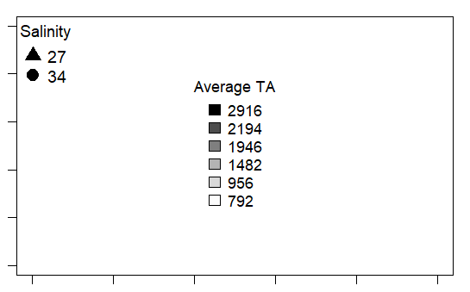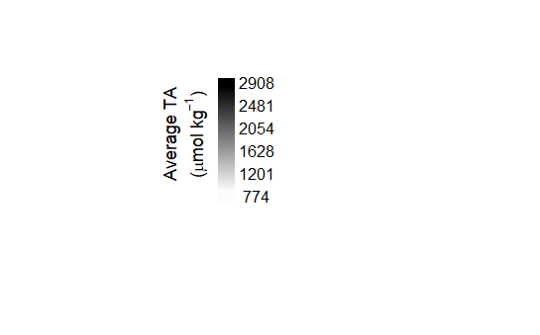

Fig. 2. Measured A) total alkalinity (TA), B) salinity and C) temperature values for each culture chamber over the 36 days. Dashed lines show the average TA value of replicate chambers (n = 2).

**ǁ**

**C**

**A**

**B**

**Statistical analysis—** All statistical tests were performed in R Studio (ver. 2022.07.02). We used a mixed effects model (*nlme*, *lme4*) to explore how TA affects growth in shell area over the course of an exposure, across two salinity levels, and as a function of initial oyster size. We explored growth responses during two temporal periods: an earlier response window (days 0-18), and a later response window (days 19-36). The initial size corresponded to the projected surface area at the beginning of the time window under consideration. Total alkalinity and initial oyster size were treated as continuous, fixed effects, whereas salinity (ambient versus low) and response window (earlier versus later) were included as categorical effects. We incorporated oyster individual and culture chamber as random intercepts to account for the lack of independence associated with repeated sampling of the same oysters and the lack of independence of oysters within a given culture. In the resulting analysis output, the effect of the earlier time window is considered the ‘default’, and as such, reported model estimates of the intercept and fixed effects (slopes) refer effects within the earlier window. T effect of the second time window appears via the interaction terms between TA or salinity and response window. We used similar models to test the influence of TA, salinity, and initial oyster size on overall growth over the full 36 days of the experiment. The influence of these latter three predictors on shell thickness (shell mass per area, mg mm-2) and condition index (tissue mass per shell mass, mg mg-2) were also tested, including culture chamber as a random intercept. We added a weighted variance term to models that failed the Breusch-Pagan test (*lmtest*) for residual heteroscedasticity, which specifies that the weight of each data point is equal to the proportional variance across bins. Assumptions of normality were visually assessed with qqplots and histograms of model residuals. We employed backwards step-wise model selection to test the effect size of parameters found significant in the model, running ANOVA comparisons between a full model and one with a given parameter omitted. The computed L-ratios, shown in Tables 1-4, indicate a proportional effect size relative to other predictors in the model, at a given p-value.

***Results—***

**Growth in shell area—** Growth in oyster shell area was higher during the earlier (0-18 d) response window than the later (19-36 d) response window (compare response scales between panels in Fig. 3). This difference was appreciable, with average oyster growth (across all treatments) during the second time window dropping from 11 to 2 mm2 , or almost ~80% of that observed during the first window of the same length. Total alkalinity did not influence growth in shell area during the earlier response window, but TA had a positive effect during the later response window (Fig. 3B; Table 1). The pattern during the later window may indicate that TA is more important in situations where rates of calcification of oysters are reduced by other factors. Salinity did not affect growth in shell area in either time window (Fig. 3, Table 1). In the earlier response window, there was a positive relationship between initial size and growth, while the relationship was reversed in the later window (Fig. 4, Table 1).

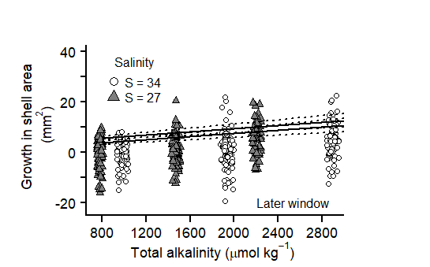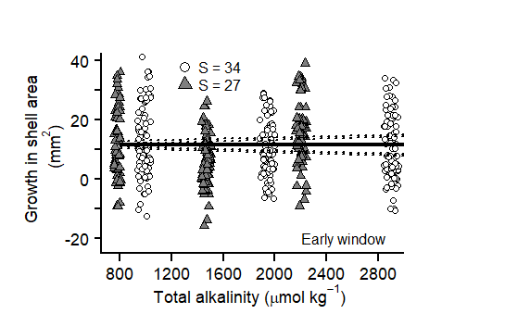

Fig. 3 Growth in shell area does not exhibit separate relationship with salinity (grayscale) in neither the A) early (0-18 days) nor B) later (19-36 days) window in juvenile *C. virginica* oysters. Model predicted intercepts and slopes (line) and SE borders (dashed line) were taken from a mixed-effects model, and therefore incorporate the effect of other model predictors (Table X).

**B**

**A**



Earlier window

Later window

**Overall shell growth, thickness and condition index—** When overall growth spanning both time windows (i.e., over the full duration of the 36-d experiment) was computed, effects of TA were no longer apparent (Fig. 5, Table 2). Likewise, salinity did not influence growth in shell area after 36 days. However, the overall growth in shell area did increase with the initial size of oysters, similar to the earlier of the two time windows (but not the later window).

.

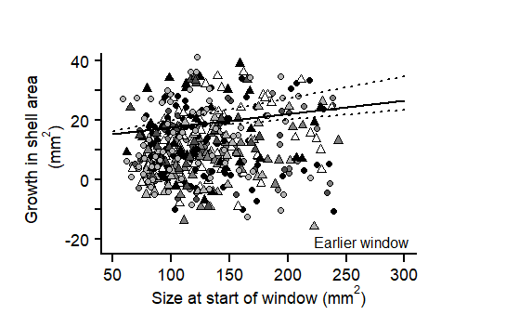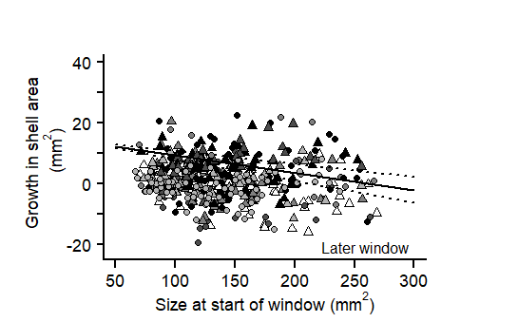

Fig. 4 Growth in shell area (unit) exhibits different relationships with size at the start of the period, between early (0-18 days) and later (19-36 days) exposure windows in juvenile *C. virginica* oysters. In the early window growth was higher in larger oysters (black points), where larger oysters exhibited lower growth in the later window (grey points). Intercept and slope model predictions (line) and SE borders (dashed lines) were taken from a mixed-effects model in Table X.



**A**

**B**

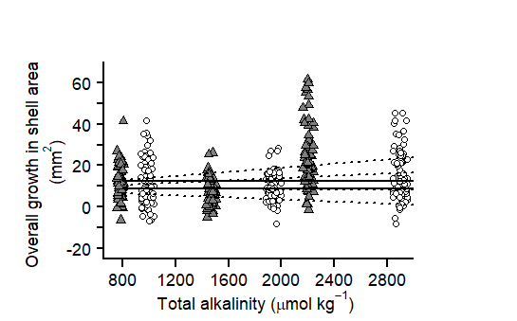

Fig. 5. Neither changes in total alkalinity (unit) nor salinity level (color) influence the relative growth in shell area (unit) of juvenile *C. virginica* oysters after 5 weeks of exposure to altered conditions. Intercept and slope model predictions (line) and SE borders (dashed lines) were taken from a mixed-effects model in Table X.

Fig. 6. Neither changes in total alkalinity (µmol kg-1) nor salinity level (color) influence A) shell thickness (mg mm2) or B) the condition index (mg mg2) of juvenile in *C. virginica* oysters. A lack of an effect of TA may suggest that trade-offs in other growth metrics, in order to maintain relative shell growth, did not occur.

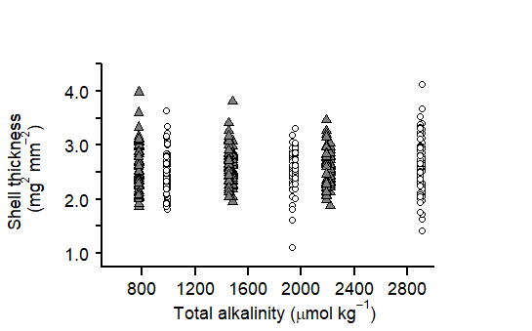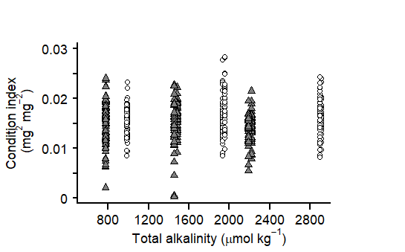

**A**

**B**

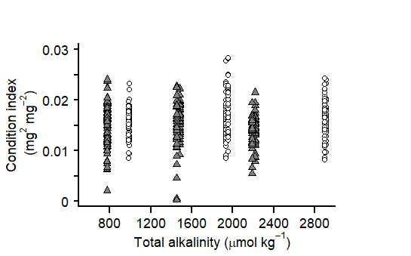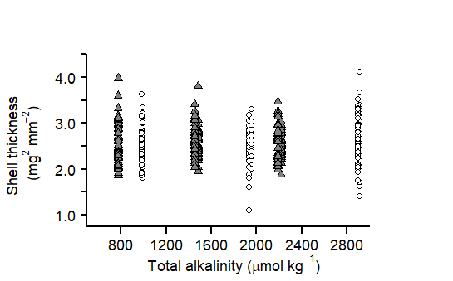

***Discussion—***Shell growth responses of juvenile *C. virginica* oysters to altered alkalinity changed over time and were uninfluenced by lower salinity.In the earlier window, growth in shell area was neither influenced by altered TA nor salinity but increased with the size of the individuals (Fig 3A), which could indicate an ability to quickly conform and grow in new conditions. In the later window we detected higher growth with higher TA, and lower shell growth in low TA conditions (Fig. 3B). These patterns combined to show no effect of TA in overall shell growth (0 – 36 days), due to the lower scale of shell growth in the later period. Oysters that were exposed to the lowest TA conditions in both salinities likely experienced an increased tendency for external shell dissolution from under-saturated seawater conditions (in respect to calcite CaCO3), though, we did not detect consequences of low TA-driven shell loss in shell growth, nor thickness (Fig. 4, 5A). Similarly, oyster condition index following the experiment was similar in all treatments (Fig. 5B). These trends may indicate the import of biological activity, both in scale and through time, in mediating the effect of seawater conditions.

The earlier negligible impact of TA on shell growth may suggest oysters' capacity to quickly acclimate and grow new shell in low TA conditions, even seawater is corrosive to shell material. Unlike studies that have demonstrated disruptions to shell building under ocean acidification conditions, including multiple focusing on *C. virginica* (cite list), we did not see an initial nor overall effect of TA. This is despite the fact that our two lowest TA treatments created sub-saturation conditions in respect to calcium carbonate (mineral form calcite). A likely possibility is that individuals were able to biologically compensate for external shell loss in a well-fed environment (cite). Additionally, in the earlier window we detected higher shell growth from oysters that were initially larger in size, which could indicate an increased surface area available to calcify onto (cite) or an ability of larger oysters (with maintained tissue reserves) to maximize shell growth (cite).

Although corrosive conditions may result from altered TA or OA conditions, they could have different mechanistic import for shell building pathways. For example, ocean acidification conditions describe the increased uptake of atmospheric CO2 in seawater without a coinciding increase in TA , which can lead to a reduction in pH. A reduction in seawater TA could also result in reduced pH, though, this is due directly reducing the buffering capacity of seawater, without modifying pCO2. Given that other coastal calcifiers have shown disruptions to shell growth under altered pCO2 conditions, it would be interesting to see whether their sensitivity to corrosive seawater also manifests under low TA.

Declines in oyster shell growth during the later window coincided with an observed effect of TA, which could result from physiological shifts away from growing shell area. It has been previously demonstrated that many calcifiers are able to overcome shell dissolution from corrosive seawater through elevating biological calcification (cite), in addition to work emphasizing the importance of high-food environments in facilitating upregulated activity (cite). We did not anticipate such a significant shift in activity, where oysters could have been shifting energy away from growing shell area to another process, like growing vertical shell (thickness) or tissue, however, we did not test this explicitly in our experiment.

Other calcifying species have also demonstrated resistance to dissolution with the presence of organic surface layers that minimize contact between seawater and underlying shell (cite). One example is the periostracum, an organic layer that is deposited prior to later shell growth in many molluscs, including *C. virginica* oysters . Although little is known about the effect of periostracum on oyster shells, prior work has quantified a significant reduction in shell dissolution when present (ptero paper).. Indeed, Zuykov et al (2012) measured low porosity of the periostracum in *C.* virginica, even though the layer appeared rough and was thinner than in other bivalves. This may indicate that the periostracum in oysters may also protect shell from seawater contact. We did not measure the extent of periostracum coverage in our oysters but did note an extreme discoloration in the shells through time as a function of TA condition (Fig 7). Bleaching of the exterior of the shell may indicate the loss of this layer and subsequent dissolution of surface shell, which could have implications for interactions with shell-boring polychates (Martinelli et al. 2020). Future work may benefit from measuring changes in activity level of other processes through time in conjunction with surface properties of the shell in order to better understand the extent to which these factors separately control shell growth.

After 36 days of exposure, there was no significant variation in oyster shell thickness or condition index in response to changes in TA or salinity, which may suggest that oyster shell growth occurred without a discernible energy trade-off. However, given that we were unable to measure thickness and condition index through time, there are multiple scenarios that could have occurred between the two time windows, to end up with a similar net result. The first, recognizes other work that has demonstrated that an increased energetic cost to maintenance in corrosive seawater can result in trade-offs in energy allocated to various processes (cite). Although we were unable to verify this through sampling, in this scenario, oysters may have initially exhibited shell thinning or less tissue growth, that was mitigated in the later period when oysters shifted energy away from shell growth. The contrast is that oyster shell thickness and condition index did not change through time, which has been shown in other marine calcifiers in high-food environments (cite). Future studies that are able to decouple naturally shifting metabolic pathways from disruptions of altered seawater conditions in *C. virginica* and other calcifying species would be beneficial.

While we observed no adverse impacts on shell growth with a salinity reduction to 27, it is worth considering that more severe declines in salinity coinciding with forecasted extreme precipitation events, could interact with the effects of TA in a different manner.Especially along the Atlantic and Gulf coast of the United States, where *C. virginica* provides vital coastal habitat and economic services, hurricanes are becoming more frequent and severe (cite). In fact, extreme precipitation events along the US West have already resulted in mass mortality of native oyster populations, though *C. virginica* may be able to tolerate declines in salinity better than other related species (cite). The extent to which *C. virginica* oysters may be able to hand shifts in TA in more drastic reductions in salinity, like those corresponding to extreme storms, could provide insight as to whether lower salinities would have a similar negligible interaction with variable TA on shell growth.

Understanding the trajectory and character of growth responses of estuarine calcifiers to changes in TA and salinity remains an area for future exploration. Our results illustrate that the effect of TA on oyster shell growth is initially negligible, highlighting their quick potential to acclimate, and overcome sometimes corrosive, new conditions. Moreover, our work shows lower shell building activity in the later window corresponding with a positive effect of TA. As more extreme changes to conditions continue to manifest, it will likely be more important to understand how growth in other calcifiers responds to changes in seawater conditions through time.

***Tables—***

Table 1. Results of a mixed effects, linear regression model testing the independent effects of total alkalinity (TA), salinity (factor, 2 levels) and size at start of window (mm2) and their interaction with time window (factor, 2 levels) on growth in shell area (mm2) of juvenile *Crassostrea virginica* oysters. L-Ratios (for significant parameters) and p-values were recorded during backward stepwise model selection and refer to the ANOVA test output between the full model and a model with the specified interaction omitted. Bolded values denote a significant effect, determined by alpha < 0.05. The final model: Growth in shell area ~ total alkalinity + factor(salinity) + factor(time window) + initial size + interaction (TA: time window) + interaction (salinity + time window) + random intercept(individual) + random intercept(culture chamber), accounted for ~ 26% of the variation. In model estimates below, the intercept refers to the effect of ambient salinity, whereas the salinity term refers to the effect of low salinity, both in the earlier time window. The TA term refers to the earlier window effect of total alkalinity, whereas the interaction term between TA and window describes the effect of TA in the later window. Similarly, the second interaction term, ‘Salinity: window’, describes the effect of salinity during the later window.

|  |  |  |  |  |  |  |
| --- | --- | --- | --- | --- | --- | --- |
| **Fixed Effects**  marg. r2 = 0.26  cond. r2 = 0.26 | **Estimate** | **Std. Error** | **t-value** | **df** | **L. Ratio** | **p-value** |
| Intercept | 13.6740 | 4.1776 | 3.2732 | 460 |  | **0.0011** |
| Salinity | 0.6498 | 0.9105 | 0.7137 | 460 |  | 0.4758 |
| Size at start of window | 0.0432 | 0.0104 | 4.1711 | 452 |  | **< 0.0001** |
| Total alkalinity (TA) | 0.0004 | 0.0006 | 0.7036 | 460 |  | 0.4820 |
| Time window | -0.4918 | 0.1461 | -3.3657 | 452 |  | **0.0008** |
| Interaction (TA: window) | 0.0032 | 0.0009 | 3.5938 | 452 | 12.9160 | **0.0003** |
| Interaction (Salinity: window) | 1.8572 | 1.2829 | 1.4476 | 452 |  | 0.1481 |
| Interaction (Size: window) | -0.0570 | 0.0140 | -4.0839 | 452 | 16.6780 | **< 0.0001** |
| **Random Effects** | **Intercept** | **Residual** |  |  | **L. Ratio** | **p-value** |
| Individual | 0.0003 | -- |  |  | 37.5120 | < 0.0001 |
| Culture chamber | 0.0003 | 9.1748 |  |  |  | 0.9996 |

Table 2. Results of a mixed effects, linear regression model testing the independent effects of total alkalinity (TA), salinity (factor, 2 levels) and initial size (mm2) on overall shell growth (mm2) in juvenile *Crassostrea virginica* oysters after 36 days. L-Ratios (significant parameters) and p-values were recorded during backward stepwise model selection and refer to the ANOVA test output between the full model and a model with the specified predictor omitted. Bolded values denote a significant effect, determined by alpha < 0.05. In the final model: Overall shell growth ~ total alkalinity + factor(salinity) + initial size + random intercept(culture chamber, the estimate for the intercept refers to the effect of ambient salinity, whereas the salinity term refers to the effect of low salinity.

|  |  |  |  |  |  |  |
| --- | --- | --- | --- | --- | --- | --- |
| **Fixed Effects**  marg. r2 = 0.12  cond. r2 = 0.42 | **Estimate** | **Std. Error** | **t-value** | **df** | **L. Ratio** | **p-value** |
| Intercept | -1.9521 | 5.5711 | -0.3504 | 450 |  | 0.7262 |
| Salinity | 3.4740 | 3.6491 | 0.9520 | 9 |  | 0.3660 |
| Initial size | 0.0517 | 0.0084 | 6.1657 | 450 | 22.3020 | **< 0.0001** |
| Total alkalinity | 0.0040 | 0.0025 | 1.5992 | 9 |  | 0.1442 |
| **Random Effects** | **Intercept** | **Residual** |  |  | **L. Ratio** | **p-value** |
| Culture chamber | 5.7455 | 8.0515 |  |  | 86.7583 | **< 0.0001** |

Table 3. Results of a mixed effects, linear regression model testing the independent effects of total alkalinity (TA), salinity (factor, 2 levels) and initial size (mm2) on shell thickness (mg mm2) in juvenile *Crassostrea virginica* oysters after 36 days. L-Ratios (significant parameters) and p-values were recorded during backward stepwise model selection and refer to the ANOVA test output between the full model and a model with the specified predictor omitted. Bolded values denote a significant effect, determined by alpha < 0.05. In the final model: Shell thickness ~ total alkalinity + factor(salinity) + initial size + random intercept(culture chamber, the estimate for the intercept refers to the effect of ambient salinity, whereas the salinity term refers to the effect of low salinity.

|  |  |  |  |  |  |  |
| --- | --- | --- | --- | --- | --- | --- |
| **Fixed Effects**  marg. r2 = 0.01  cond. r2 = 0.01 | **Estimate** | **Std. Error** | **t-value** | **df** | **L. Ratio** | **p-value** |
| Intercept | 2.4537 | 0.0925 | 26.5246 | 450 |  | **< 0.0001** |
| Salinity | 0.0069 | 0.0403 | 0.1523 | 9 |  | 0.8823 |
| Initial size | 0.0002 | 0.0005 | 0.4743 | 450 |  | 0.6355 |
| Total alkalinity | 5.920e-05 | 3.1130e-05 | 1.9202 | 9 |  | 0.0895 |
| **Random Effects** | **Intercept** | **Residual** |  |  | **L. Ratio** | **p-value** |
| Culture chamber | 2.5337e-05 | 0.4574 |  |  |  | 0.9997 |

Table 4. Results of a mixed effects, linear regression model testing the independent effects of total alkalinity (TA), salinity (factor, 2 levels) and initial size (mm2) on condition index (mg mg-2) in juvenile *Crassostrea virginica* oysters after 36 days. L-Ratios (significant parameters) and p-values were recorded during backward stepwise model selection and refer to the ANOVA test output between the full model and a model with the specified predictor omitted. Bolded values denote a significant effect, determined by alpha < 0.05. In the final model: Condition index ~ total alkalinity + factor(salinity) + initial size + random intercept(culture chamber, the estimate for the intercept refers to the effect of ambient salinity, whereas the salinity term refers to the effect of low salinity.

|  |  |  |  |  |  |  |
| --- | --- | --- | --- | --- | --- | --- |
| **Fixed Effects**  marg. r2 = 0.16  cond. r2 = 0.32 | **Estimate** | **Std. Error** | **t-value** | **df** | **L. Ratio** | **p-value** |
| Intercept | 0.0116 | 0.0016 | 7.0949 | 450 |  | **< 0.0001** |
| Salinity | -0.0018 | 0.0011 | -1.7086 | 9 |  | 0.2205 |
| Initial size | 3.3018e-05 | 3.7727e-06 | 8.7517 | 450 | 65.1080 | **< 0.0001** |
| Total alkalinity | 2.080e-07 | 7.2360e-07 | 0.2877 | 9 |  | 0.4677 |
| **Random Effects** | **Intercept** | **Residual** |  |  | **L. Ratio** | **p-value** |
| Culture chamber | 0.0016 | 0.0033 |  |  | 49.1364 | **< 0.0001** |